1.Java file in Nano editor

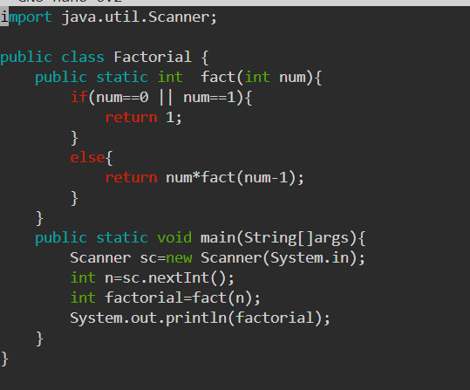

2.Execution of java

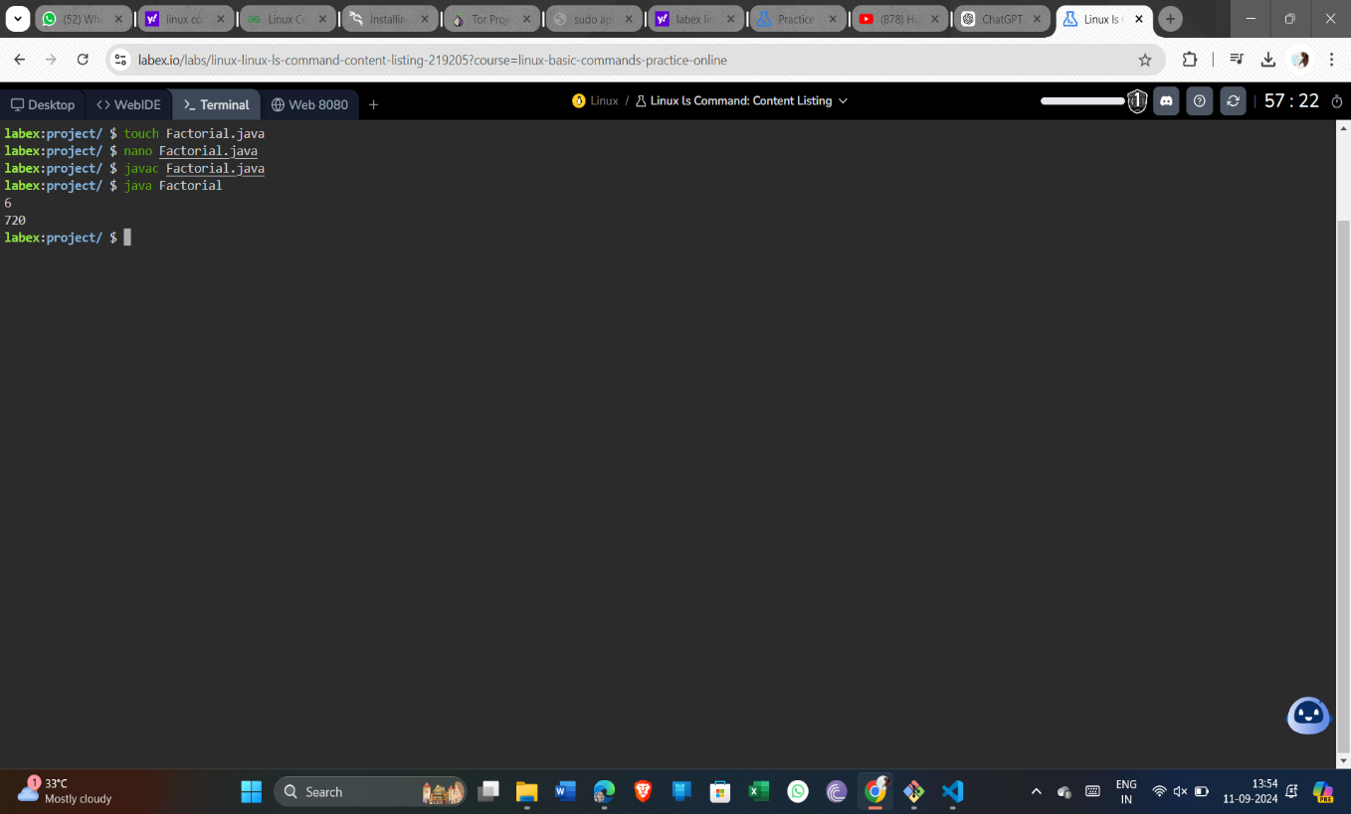

3.C file in Nano editor

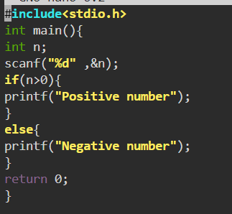

4. Execution of c file

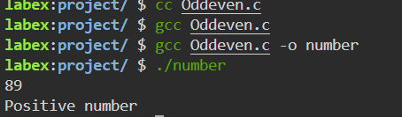

5.Shell file in Nano editor

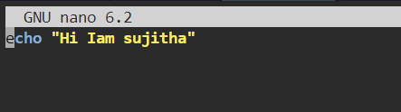

6.Execution of shell script file

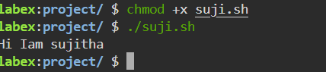

7.Network Configuration

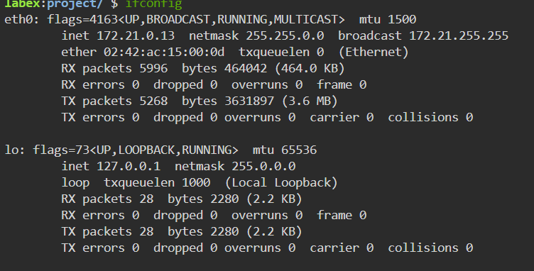

8.Change Ownership

